**🍁Plant Leaf Disease Detection🍁**

**Introduction**

The agricultural sector faces a significant challenge: the growing need to increase global food production by 70% by 2050 to meet the demands of an expected population exceeding 9 billion. One of the major obstacles to achieving this goal is crop yield loss caused by infectious plant diseases, which reduce potential yields by an average of 40%. In developing regions, farmers often face even more severe losses, with some experiencing up to 100% yield reductions.

The goal of this project is to use the PlantVillage dataset to train machine learning models capable of recognizing different plant diseases. The project will involve evaluating multiple classification models, assessing their performance through metrics such as accuracy, precision, recall, and F1 score, and visualizing the results through confusion matrices and performance heatmaps. The outcome will be an effective tool for disease identification, providing real-time support to farmers in safeguarding their crops and increasing food production sustainability.

**About Dataset**

In this context, the PlantVillage dataset, consisting of over 50,000 expertly curated images of healthy and diseased crop leaves, offers a critical resource. Leveraging advances in machine learning and computer vision, this dataset supports the development of automated, mobile-based disease diagnostics that can empower farmers around the world. By turning smartphones into powerful diagnostic tools, the project aims to help farmers identify diseases early and take timely action to prevent devastating crop losses.

The dataset covers 14 different crop species, including Apple, Tomato, Grape, Corn, and Potato, among others. Additionally, it identifies 38 distinct diseases that affect these plants, such as Apple Scab, Black Rot, and Tomato Leaf Mold. This diversity of plant species and diseases makes the dataset highly valuable for developing robust plant disease recognition models.

This dataset offers the potential to improve disease diagnostics by enabling the development of mobile applications that can help farmers around the world, especially in developing regions, diagnose plant diseases early and accurately.

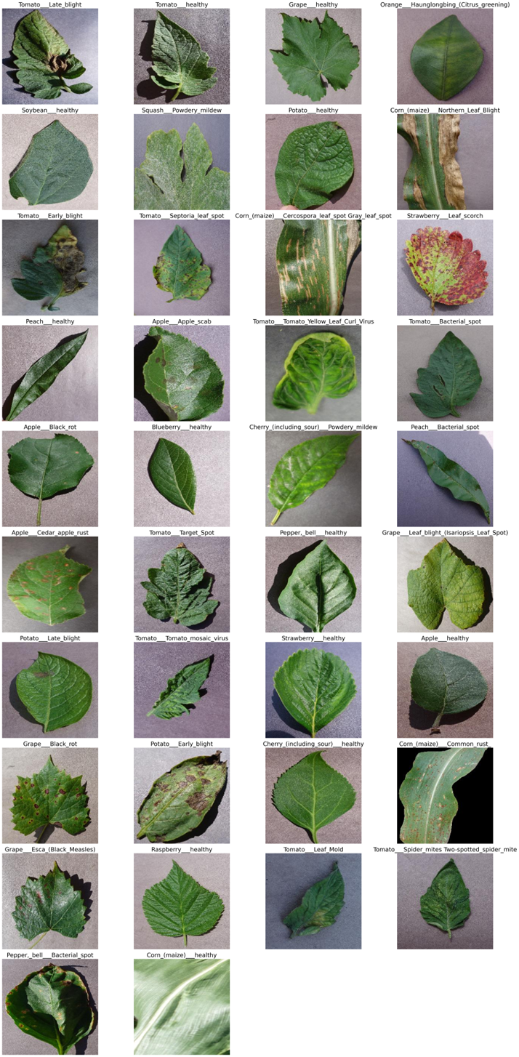

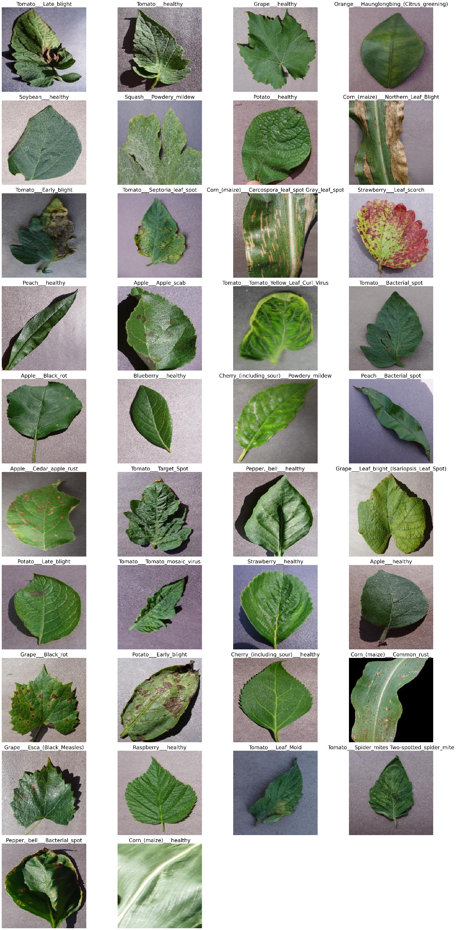

**Image Preprocessing Steps**

**Loading the Image**: The image is read from the specified file path using cv2.imread(), which loads the image in BGR color format.

1. **Grayscale Conversion**: The color image is converted into a grayscale version using cv2.cvtColor(). This simplifies the image by removing color information and focusing only on intensity, making further processing faster and more efficient.
2. **Gaussian Blurring**: A Gaussian blur is applied using cv2.GaussianBlur(), which smooths the image by reducing noise and fine details. This helps in improving the accuracy of thresholding by reducing variations in pixel intensity.
3. **Otsu's Thresholding**: Otsu's method is applied to automatically determine an optimal threshold value for converting the image into a binary form. This step creates a black-and-white image where the objects of interest are separated from the background.
4. **Inversion**: The binary image is inverted using cv2.bitwise_not() to ensure the object of interest becomes white and the background becomes black. This is necessary for the next step.
5. **Dilation**: Dilation is performed on the inverted image using cv2.dilate(), which helps to expand the white regions (foreground objects). This can enhance the object edges and make it more prominent.
6. **3-Channel Conversion**: The dilated image, originally in a single-channel grayscale format, is converted back to a 3-channel image using cv2.cvtColor() to match the original image's format for subsequent operations.
7. **Bitwise AND Operation**: A bitwise AND operation is performed between the original image and the processed binary image, allowing the foreground object to be extracted from the background.

This sequence of steps enhances the quality of the image by focusing on the key features and making it suitable for further analysis or machine learning applications.

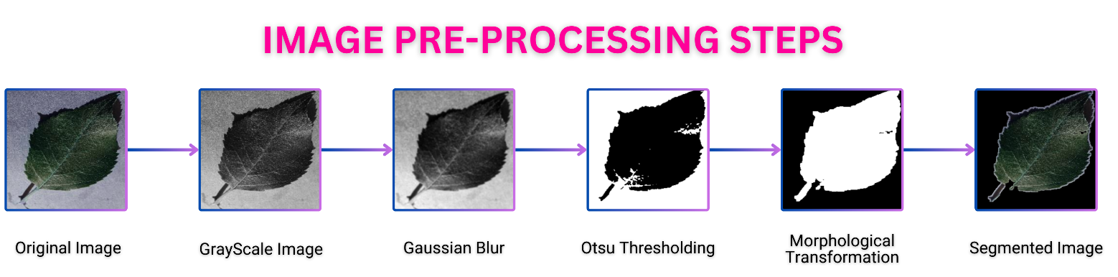

**Feature Extraction**

1. **Image Preprocessing**: The input image is pre-processed to enhance the key features, followed by converting it to grayscale.
2. **GLCM (Gray Level Co-occurrence Matrix)**:
   * The grayscale image is analyzed using GLCM, which captures the texture features by measuring pixel intensity relationships at specific angles (0°, 45°, 90°, and 135°).
   * From GLCM, texture features such as **Contrast**, **Dissimilarity**, **Homogeneity (IDM)**, **Energy**, and **Correlation** are computed.
   * The mean values of these features across all directions are taken for better representation.
3. **HSV Color Space**:
   * The preprocessed image is converted to the HSV (Hue, Saturation, Value) color space.
   * The **mean** and **standard deviation** for each channel (Hue, Saturation, and Value) are calculated, which capture the color distribution characteristics.
4. **RGB Channel Statistics**:
   * The image is split into **Red**, **Green**, and **Blue** channels.
   * The **mean** and **standard deviation** for each channel are computed, providing color intensity insights.
5. **Contour-based Features**:
   * The grayscale image is thresholded to identify contours.
   * From the largest contour, the **area** and **perimeter** are calculated, representing the shape and size of the object in the image.

The combined GLCM and HSV features provide both texture and color information, making the feature set robust for image classification or analysis tasks.

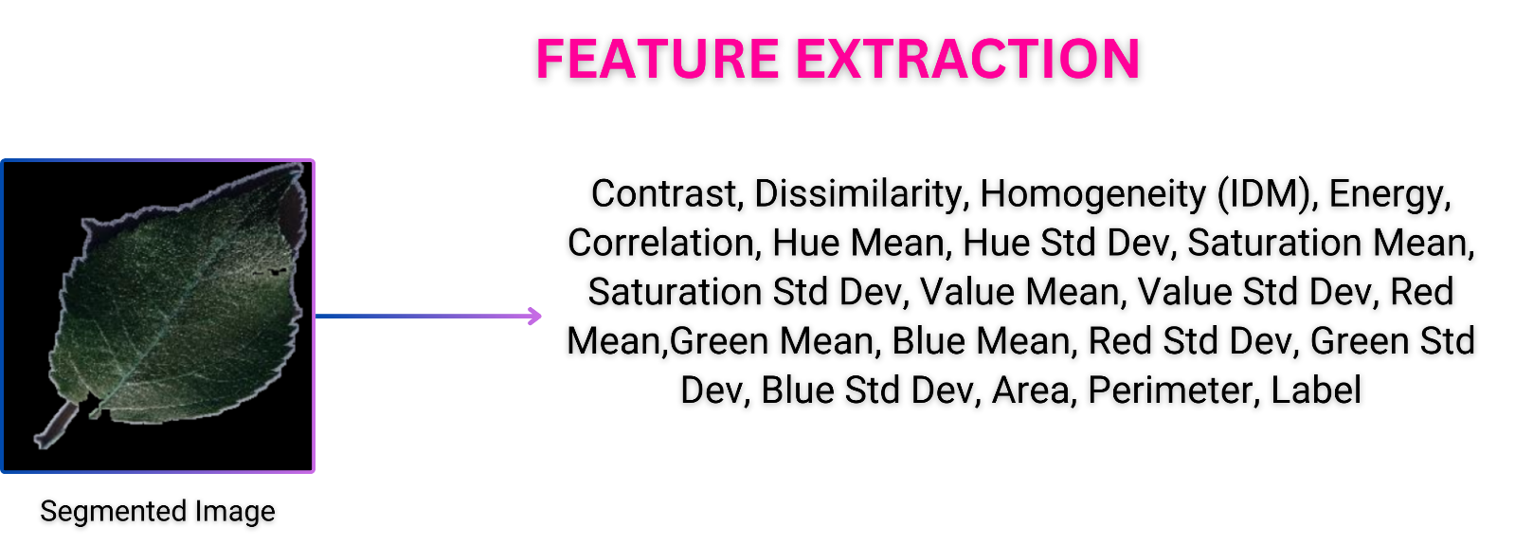

**Model Training & Evaluation**

The model you're using for training is a **CatBoost Classifier**, which is a powerful gradient boosting algorithm designed to handle categorical data efficiently. Here's a summary of the training process:

1. **Data Splitting**: The input dataset is split into features (X) and the target label (y). It is further divided into training and testing sets, with 20% of the data reserved for testing. Stratified sampling ensures class distribution is preserved across both sets.
2. **CatBoost Classifier**: The model used is the **CatBoostClassifier**, configured with:
   * **Iterations**: 2000, meaning the model will go through 2000 boosting iterations.
   * **Learning Rate**: 0.1, controlling the step size at each iteration to improve model convergence.
   * **Depth**: 5, limiting the complexity of each decision tree.
   * **Random Seed**: 42, ensuring reproducibility.
   * **Verbose**: 0, suppressing training logs for cleaner output.
3. **Model Training**: The classifier is trained on the training dataset (X_train and y_train).

CatBoost is known for its high performance, particularly in handling categorical data and delivering faster training times without extensive parameter tuning.

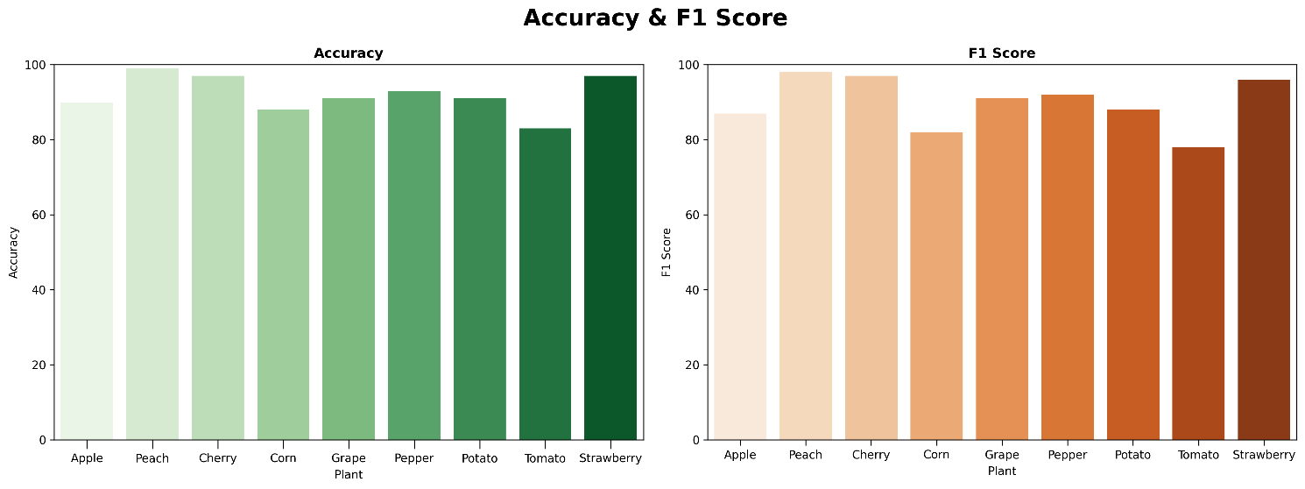 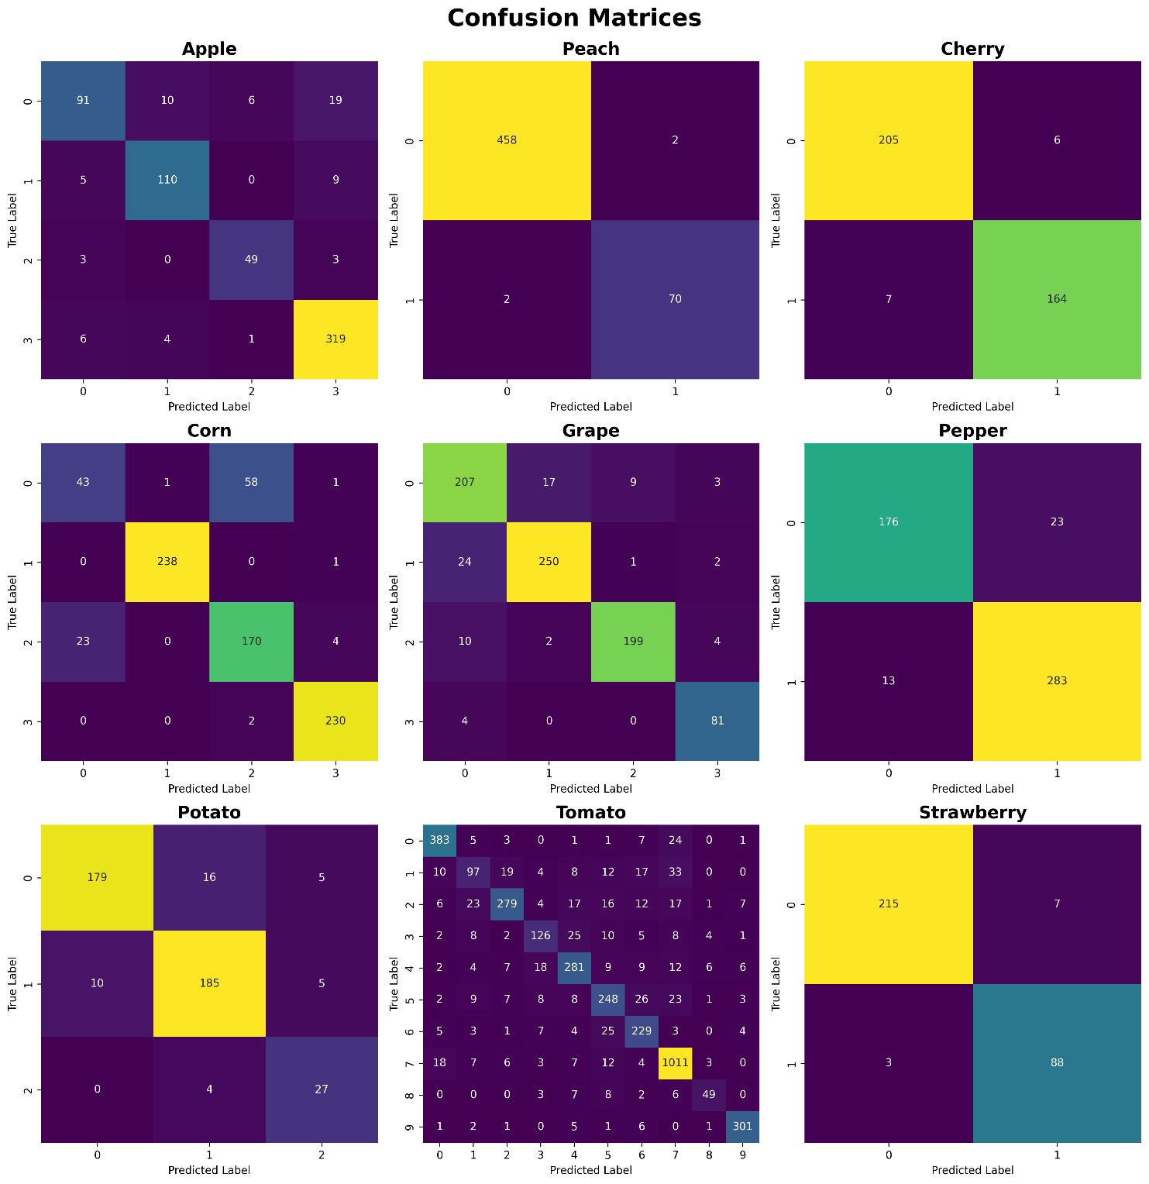 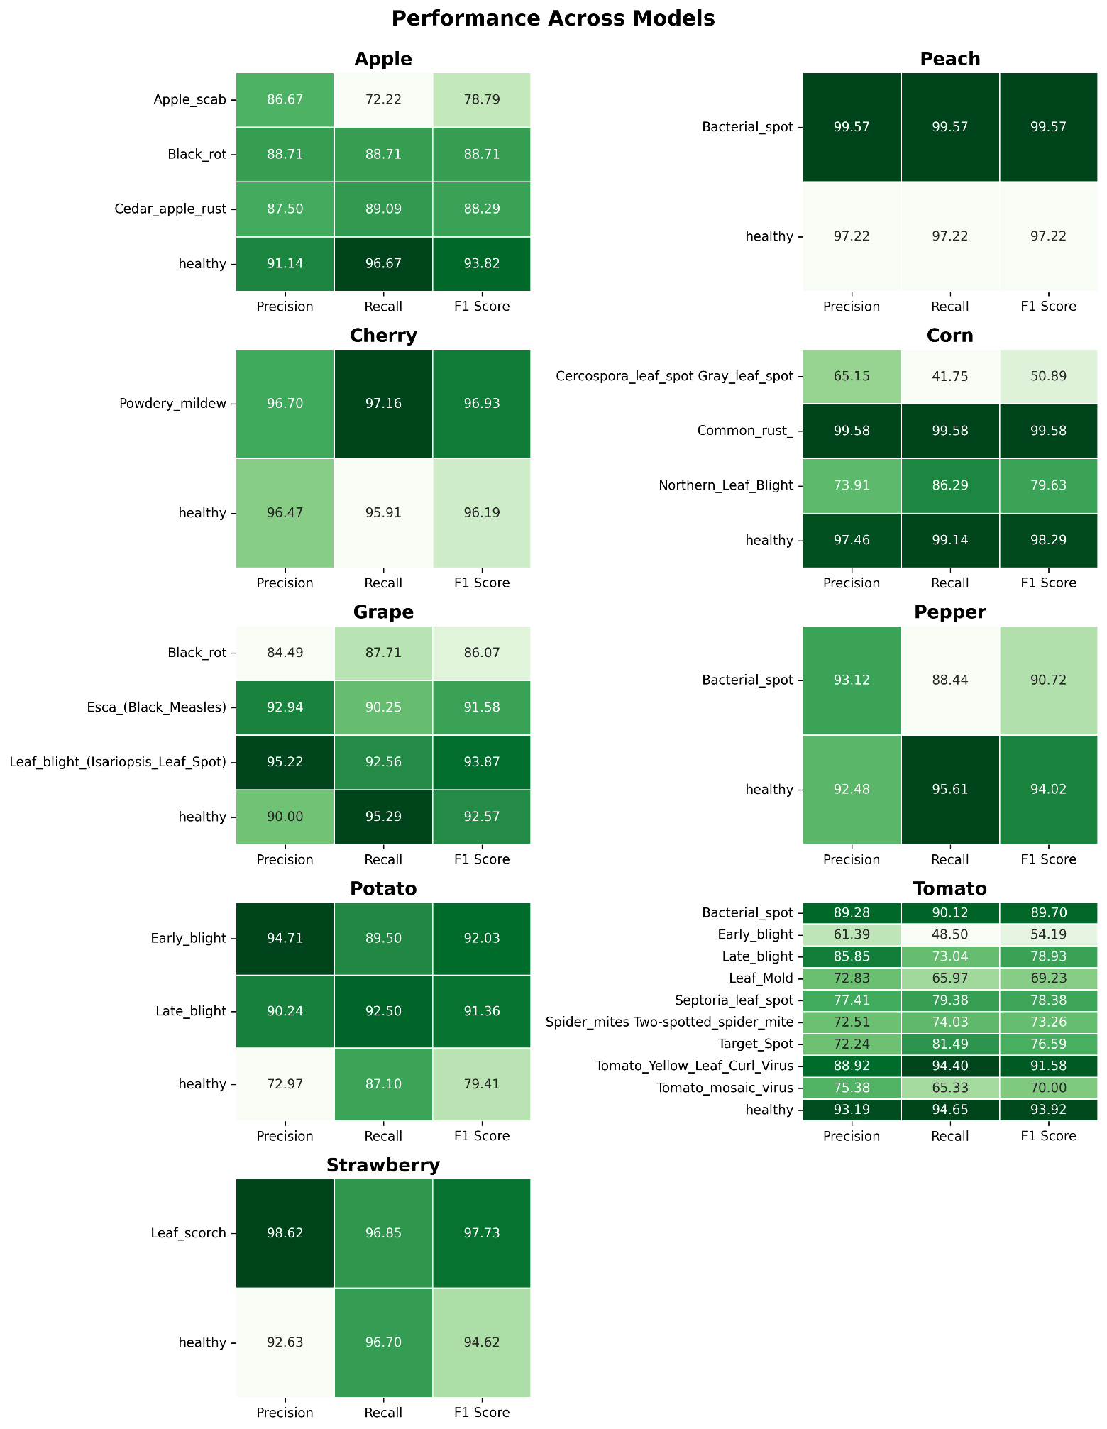

**Application Screenshots**

